This document is intended for CompuMark law firms and partners to build in their branded templates and share with their clients

As long as the template is active on CompuMark’s Watch Resource Center, CompuMark Watch Customers may use this template to create a Customer branded document to share with their clients. Customer understands that they must check the Resource Center regularly to ensure the template is still in use and that Customer is using the most current version of the template. Customer agrees that CompuMark may terminate permission to use the template at any time.
Trademark Watching

Guard your brand and protect your investment

Strong brands deserve strong protection
Your trademark – your product or service name, symbol or logo – is one of your company’s most valuable assets. Because of its power to drive product recognition, customer loyalty and market opportunities, a strong trademark has substantial value. It’s not unusual for companies to invest millions in building their brands over time.
However, that value can be compromised. With rising global trademark filings, proliferating online and offline channels, exploding social media and web content, valuable brands are more vulnerable than ever before. Trademark confusion, infringement and theft can occur at any time, without your knowledge, with significant impact to your bottom line.

"Trademark confusion, infringement and theft can occur at any time, without your knowledge, with significant impact to your bottom line."

Consider the following common examples:
- A company or product of lesser quality uses a mark similar to yours, knowingly or unknowingly, confusing consumers and impacting your brand equity.
- Your trademark or brand is used generically, diluting its value to your company.
- Your trademark or brand is used on a website without proper authorization.
- Your product or counterfeit products are sold without your authorization on Internet auction sites.

The value of watching
Proactive trademark watching is one of the most important ways to protect your brand. Trademark watching services monitor trademark applications, publications and/ or use, systematically identifying exact and confusingly similar marks, unauthorized brand usage and infringement – notifying you when conflicting marks are identified.
Today, many companies consider trademark watching a cost-effective, “must have” insurance to help protect their valuable brands and manage business risk.

Is someone imitating your brand?
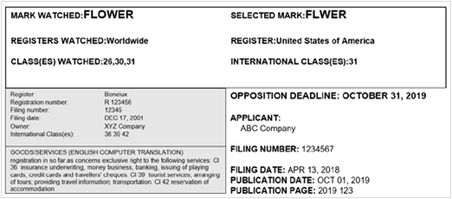
Not an actual record, provided for illustrative purposes.

Experience you can rely on
Trademark watching requires specialized experience and resources. Powered by CompuMark, [Insert Law Firm Name] has the knowledge and extensive resources – including proprietary global databases – to help uncover marks that might be overlooked by manual trademark watching.
Using CompuMark trusted products with [Insert Law Firm Name] as your trademark watching partner, you receive rapid notification of potential conflicts – so you can act quickly to protect your valuable brand assets.
We offer a range of watching services tailored to your needs:

Trademark Watching
We alert you to trademarks that may be confusingly similar to yours, including word marks, logos and slogans. Timely reports provide clear, concise information, with free translations on request.
Provides coverage around the world, including more than 200 countries.

Comprehensive coverage
Our Watch coverage spans the full spectrum of trademark-rich common law and digital channels. Optimize your coverage, decreasing your chances of missing critical marks.
Coverage Includes:
- Word and design marks
- Domain names (including ccTLDs, new and legacy gTLDs)
- Social media usernames
- Mobile app names
- International business names
- Non-Latin character marks
- Watch an entire class
- Watch by applicant

Web Watch
Watch the web for potential trademark abuse while watching your budget and saving valuable time. For a remarkably affordable cost, our Web Watch service provides a customized watch strategy to identify cases of trademark use or abuse that could negatively impact your brand – including unauthorized or generic trademark use, derogatory references, and confusing similarity. And Web Watch saves you time, too. Using CompuMark products to sift through millions of hits, we deliver concise and actionable reports that pinpoint the results that matter most.
So, you can make confidence decisions and act quickly to protect your brand.

Watch on SERION®
Enjoy the convenience of managing all your watching activities via CompuMark’s SERION online trademark environment. Manage your trademark watch portfolio, review watch notices, create and share reports and collaborate across offices.

Contact information

To request an International Business Name Watch, please contact [Insert Law Firm Name] today.

compumark.com
clarivate.com

